Lesson 3 Demo 1: Git Set-up

This section will guide you to:

* Install and set up a Git account

This lab has four sub-sections, namely:

1. Creating an account with Github
2. Downloading and installing the git command line tool
3. Generating SSH keys
4. Adding an SSH key to your git account

**Please Note:** Git is already installed in your lab. Moreover, you should already have a GitHub account from the **Git and GitHub Training** course. If yes, then skip **Step 1**.

**Step 1:** Creating an account with Github

* Open the browser in your lab and navigate to <https://github.com/>.
* The welcome window page will display a sign-up form as shown below. In the sign-up form, enter a **username**, **password**, and **email id**.



* Click on the ***Sign up*** *for GitHub* button.
* Follow the on-screen instructions to confirm that you are a human and **verify** your account.
* Select the **Free plan** and click on the choose button. GitHub will now send a verification mail to the email you provided in the second step.
* Click the *Verify email address* button in the message received from GitHub.
* Review your plan selection and click on ***Continue***. You can also choose whether you want to receive updates from GitHub via email by checking or unchecking the***Send me updates***box.
* GitHub displays a quick survey that can help you tailor your experience to match what you're looking for. Choose your preferences and click ***Submit***. You'll be taken to a screen that allows you to set up your first repository as shown below.

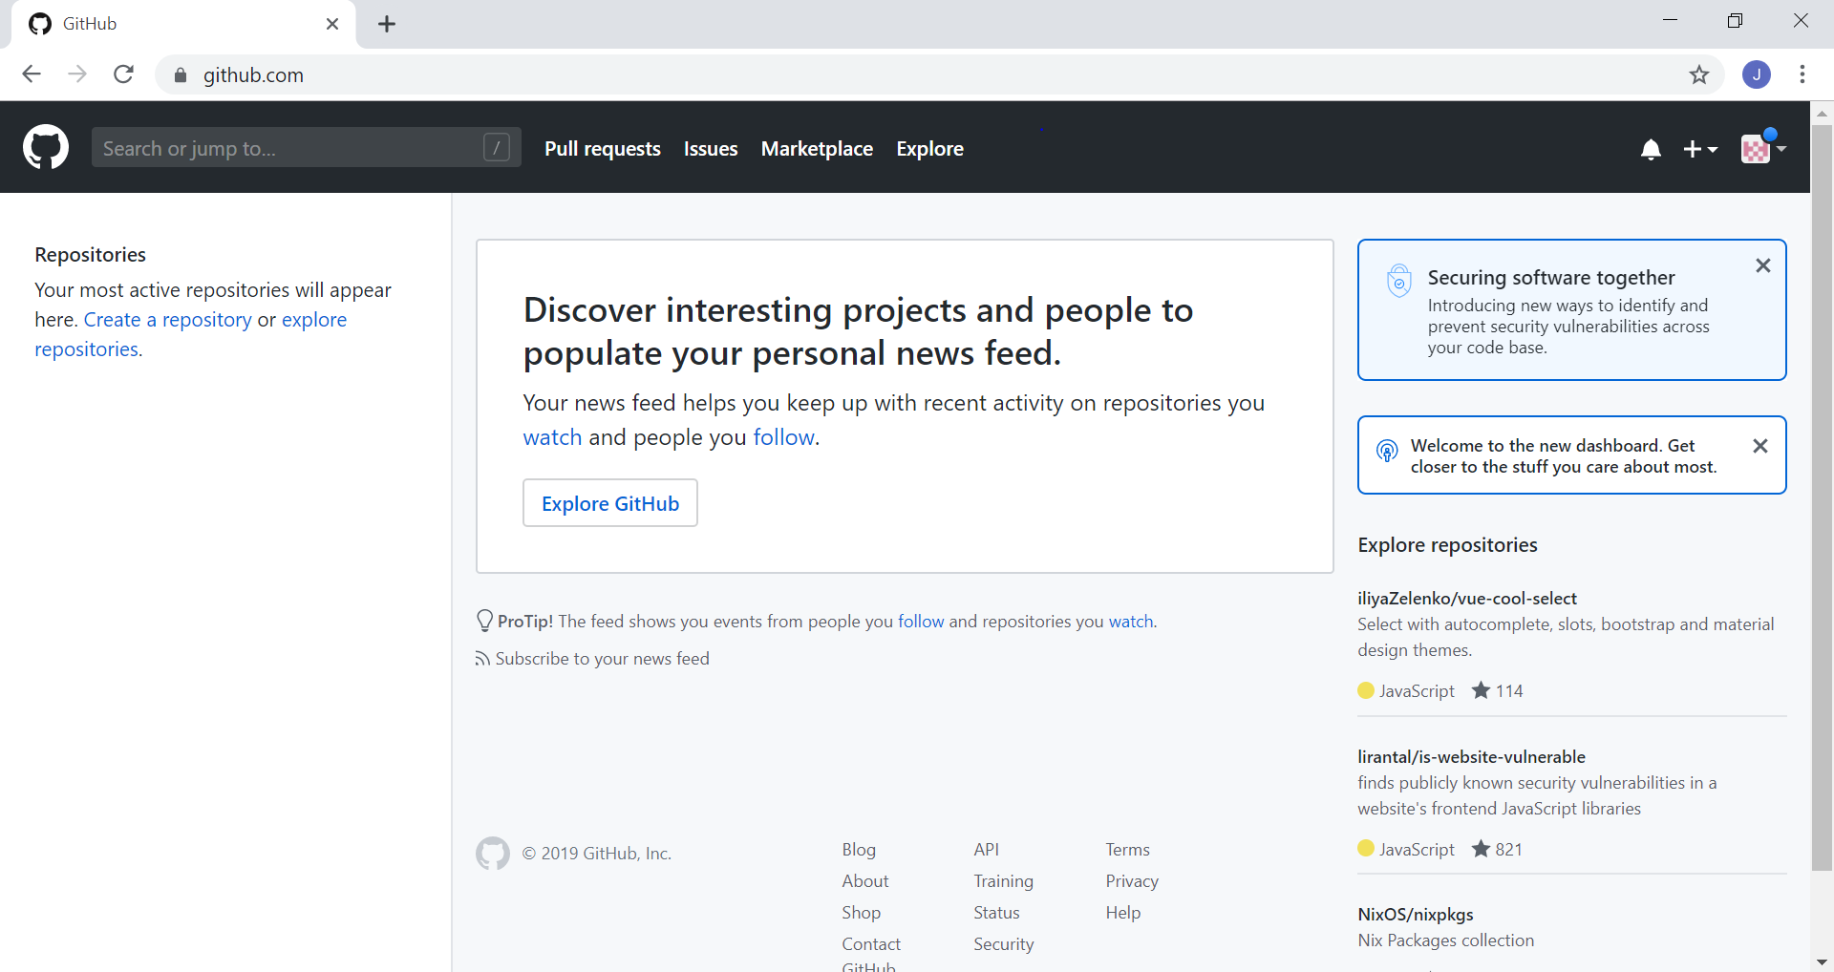

**Step 2:**  Downloading and installing the git command line tool

* Open the terminal.
* Run ***sudo apt-get install git-core*** to install git.
* Enter your password, if prompted.
* Run ***git --version*** to verify the installation.
* The command will display the version of git that was installed.

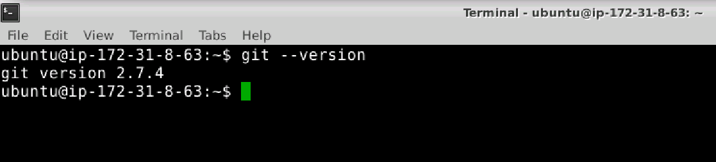

**Step 3:**  Generating SSH keys

* Open the terminal.
* Run **ssh-keygen -t rsa -b 4096 -C <YourEmailId>**, substituting in your GitHub email address. This creates a new SSH key, using the provided email as a label.
* Press ***Enter*** to accept the default when prompted for the file location where the key should be stored.
* Enter a **password** when prompted for passphrase. Press **Enter** for no passphrase.
* Verify the passphrase. This will generate the SSH key as shown below:

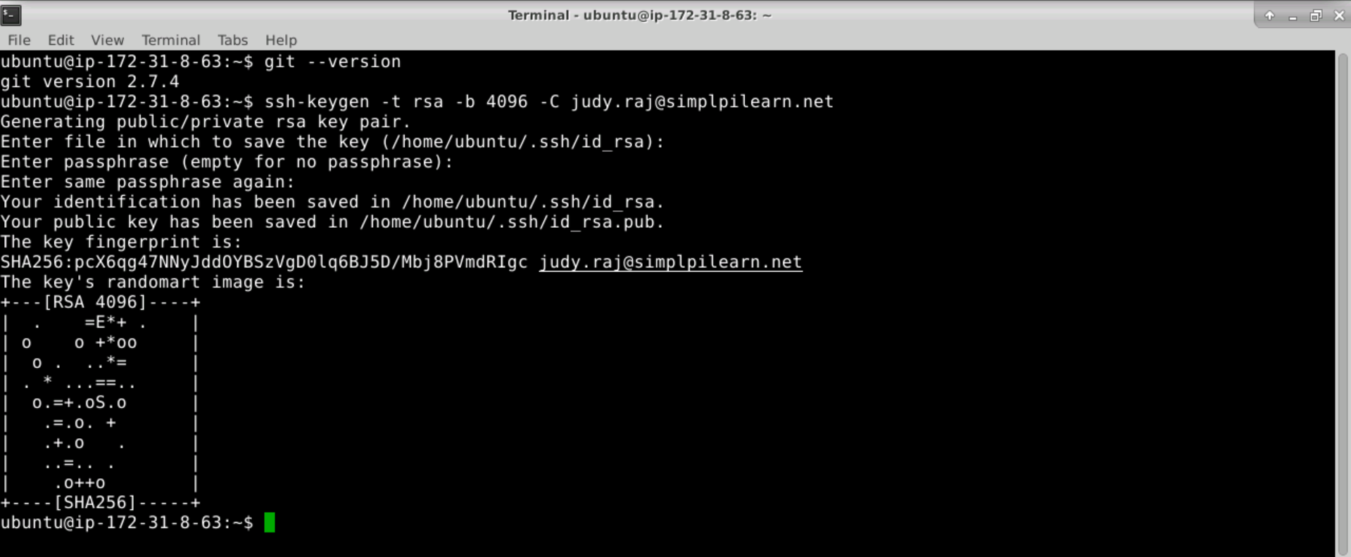

* Run ***eval "$(ssh-agent -s)"*** to get the agent process id.
* Run ***ssh-add ~/.ssh/id_rsa*** to add the SSH key to the SSH agent.
* Run ***cat < ~/.ssh/id_rsa.pub*** to display the key. Copy it to the clipboard.

**Step 4:** Adding an SSH key to your git account

* Open your browser and navigate to **github.com**
* In the upper-right corner of the page, click on your **profile photo** → then click on **Settings**.
* Click on **SSH *and GPG keys*** in the user settings sidebar.
* Click on the ***New SSH Key*** button.
* Enter a descriptive label for the key in the title field.
* Paste the SSH key into the key field and click on the ***Add SSH Key*** button.
* Enter your password when prompted.
* Your key will now show under SSH keys as shown below:

